Ideation Phase
Define the Problem Statements: Weather

Date | 30 September 2026
Team ID | SWTID-2026-1362
Project Name | Weather Wise
Maximum Marks | 2 Marks

Weather Problem Statement Template:
Create a problem statement to understand the weather app user's point of view. This template helps you focus on what matters to users, such as accurate forecasts, timely alerts, and easy-to-read weather information.
A well-articulated problem statement allows you and your team to find the ideal solution for the weather-related challenges users face, such as unexpected rain, missed storm warnings, or unclear data. Throughout the process, you’ll also be able to empathize with your users, which helps you better understand how they perceive your weather product or service.

Reference: https://miro.com/templates/customer-problem-statement/
Example:
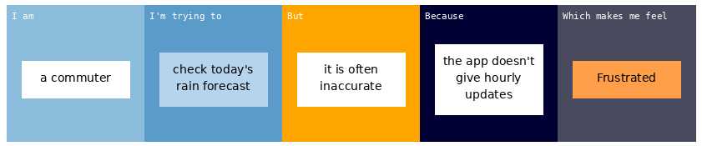
Problem Statement (PS) | I am (User) | I’m trying to | But | Because | Which makes me feel
PS-1 | a commuter | check today's rain forecast | it is often inaccurate | the app doesn't give hourly updates | Frustrated
PS-2 | a farmer | get early warnings for storms and heavy rain | alerts arrive too late | notifications are not location-based | Anxious and unprepared

